WEEK 4 – PREDICTIVE MODELING AND OPTIMIZATION
IN LOGISTICS SYSTEMS
Strategic Logistics Data Analysis for Delivery Performance and Route Optimization
Submitted By | Yash Patil
Internship Role | Logistics Data Analyst Intern
Internship Domain | Logistics Data Analytics
Project Focus | Delivery-time prediction and logistics optimization

1. Executive Summary
Week 4 extends the exploratory work from Weeks 1–3 into predictive analytics and operational optimization. The objective is to forecast shipment delivery time using a hypothetical logistics dataset and then translate the model outputs into practical optimization strategies. The analysis compares Linear Regression, Decision Tree Regression, and Random Forest Regression. Model performance is evaluated using MAE, RMSE, and R², followed by 5-fold cross-validation and hyperparameter tuning for the Random Forest model. An illustrative optimization scenario then tests how shorter routes, improved warehouse loading discipline, and higher vehicle utilization could affect predicted delivery time. All numerical results in this report are based on simulated data and are intended for internship learning and methodology demonstration, not as claims about a real logistics company.

2. Problem Definition
The logistics problem addressed in this assignment is delivery-time forecasting. Logistics teams need an estimate of expected delivery time before or during shipment planning so that they can allocate vehicles, consolidate loads, prioritize time-sensitive orders, and identify shipments that may require intervention.
- Prediction target: delivery_time_days.
- Prediction unit: one shipment record.
- Primary users: logistics planners, operations analysts, and dispatch teams.
- Business purpose: support proactive delivery planning and resource allocation.
- Optimization objective: reduce predicted delivery time while improving route and resource utilization.

3. Hypothetical Dataset and Data Simulation
A hypothetical dataset of 1,500 shipment records was simulated in Python. The design follows the logistics variables used in earlier internship weeks so that Week 4 remains consistent with the overall project. The target variable is delivery time in days. Predictor variables describe distance, shipment volume, cost, fuel usage, order value, warehouse loading, vehicle utilization, and operating region.
Feature | Type | Description
region | Categorical | Operating region
shipment_volume | Numeric | Number of shipment units
distance_km | Numeric | Estimated route distance
transport_cost | Numeric | Transportation cost
fuel_cost | Numeric | Fuel-related logistics cost
order_value | Numeric | Order value
warehouse_load | Numeric | Warehouse workload/load ratio
vehicle_utilization | Numeric | Vehicle utilization ratio
delivery_time_days | Target | Delivery time to forecast

4. Data Preparation
The preprocessing approach follows the quality-control principles established in Week 2. Missing numeric values are handled with median imputation, while missing categorical values use the most frequent category. Region is one-hot encoded. The train-test split uses 80% of observations for training and 20% for testing. A fixed random state is used to make the demonstration reproducible.
from sklearn.model_selection import train_test_split
from sklearn.compose import ColumnTransformer
from sklearn.preprocessing import OneHotEncoder
from sklearn.impute import SimpleImputer
from sklearn.pipeline import Pipeline
X = df.drop(columns=["delivery_time_days"])
y = df["delivery_time_days"]
X_train, X_test, y_train, y_test = train_test_split(
X, y, test_size=0.20, random_state=42
)

5. Model Selection and Rationale
Three regression approaches were selected to provide a transparent baseline and progressively more flexible models.
- Linear Regression: provides an interpretable baseline and tests whether the target can be approximated by additive linear relationships.
- Decision Tree Regression: captures non-linear rules and interactions between logistics variables without requiring a linear relationship.
- Random Forest Regression: combines multiple decision trees and can model complex non-linear relationships while reducing the instability of a single tree.

5.1 Model Training
models = {
"Linear Regression": LinearRegression(),
"Decision Tree": DecisionTreeRegressor(
random_state=42, max_depth=8, min_samples_leaf=8
),
"Random Forest": RandomForestRegressor(
random_state=42, n_estimators=180,
max_depth=12, min_samples_leaf=3
)
}
for name, model in models.items():
pipeline = Pipeline([
("preprocessor", preprocessor),
("model", model)
])
pipeline.fit(X_train, y_train)
predictions = pipeline.predict(X_test)

6. Evaluation Metrics and Validation
MAE measures the average absolute prediction error in days and is easy to interpret operationally. RMSE gives greater weight to larger errors, making it useful when unusually inaccurate delivery estimates are costly. R² describes the proportion of target variability explained by the model.
mae = mean_absolute_error(y_test, predictions)
rmse = mean_squared_error(y_test, predictions) ** 0.5
r2 = r2_score(y_test, predictions)
Model | MAE (days) | RMSE (days) | R²
Linear Regression | 0.280 | 0.352 | 0.843
Decision Tree | 0.341 | 0.418 | 0.779
Random Forest | 0.295 | 0.368 | 0.828
Across the initial test comparison, the Random Forest model produced an RMSE of 0.368 days and an R² of 0.828. The tuned Random Forest achieved MAE 0.296 days, RMSE 0.368 days, and R² 0.828 on the held-out test set. These values describe the simulated dataset only.
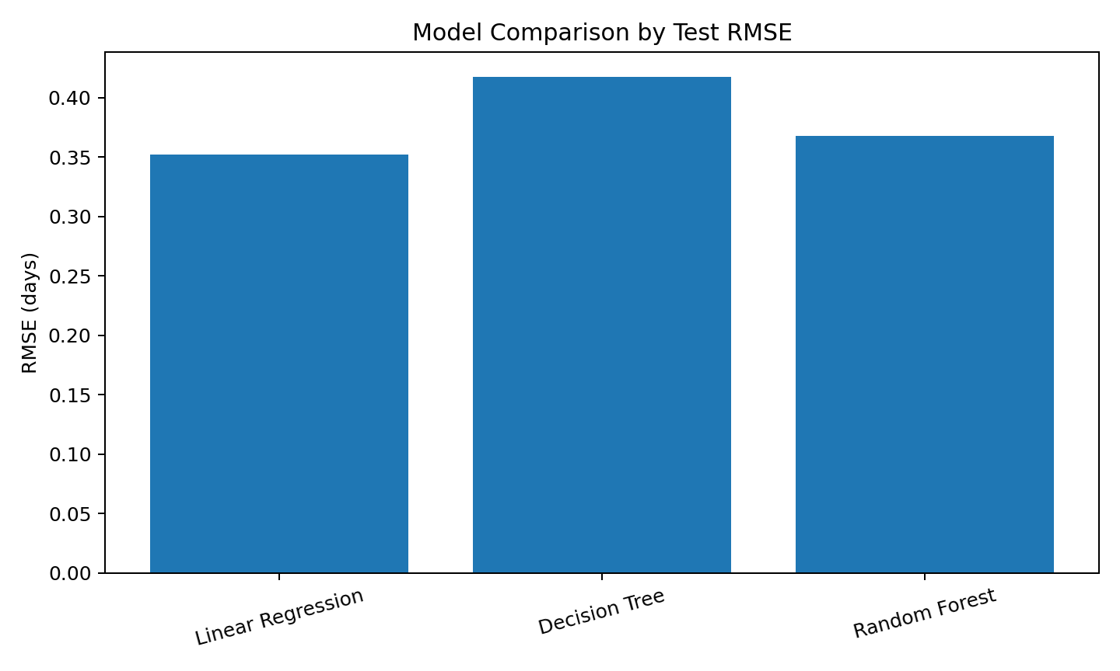
Figure 1. Comparison of test RMSE across the three predictive models.

6.1 Cross-Validation and Hyperparameter Tuning
Five-fold cross-validation was used as an additional stability check for the Random Forest pipeline. The mean cross-validated R² was 0.849 with a standard deviation of 0.016. The mean cross-validated RMSE was 0.354 days. GridSearchCV then tested combinations of tree count, maximum tree depth, and minimum leaf size using three-fold cross-validation on the training data.
Best hyperparameters found by GridSearchCV: {'model__max_depth': 12, 'model__min_samples_leaf': 4, 'model__n_estimators': 180}.
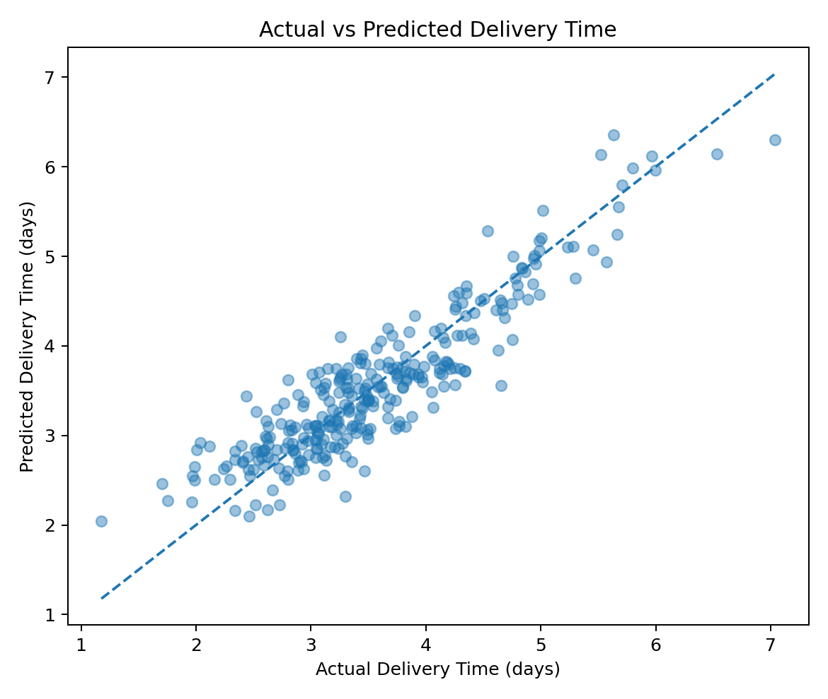
Figure 2. Actual versus predicted delivery time for the tuned Random Forest test set.

7. Feature Importance and Operational Interpretation
Feature importance from the tuned Random Forest provides a directional view of which inputs contribute most to the model's predictions. Importance is not the same as causation. It should therefore be used as a planning signal and investigated with operational data before any policy change is implemented.
- distance_km: 0.868
- warehouse_load: 0.058
- transport_cost: 0.024
- fuel_cost: 0.012
- order_value: 0.011
- vehicle_utilization: 0.010
- shipment_volume: 0.008
- region: region_West: 0.004
- region: region_East: 0.003
- region: region_North: 0.001
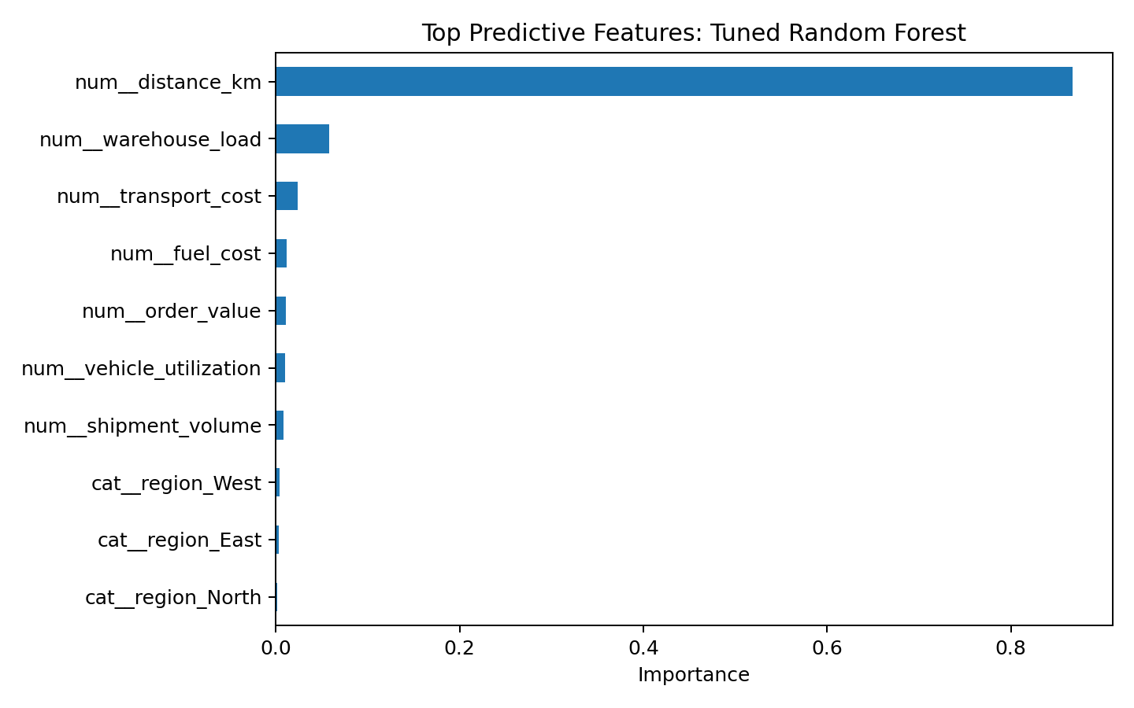
Figure 3. Top predictive features in the tuned Random Forest model.

8. Optimization Strategies
Prediction becomes operationally useful when it is linked to decisions. The following strategies are proposed from the model signals and the logistics context.
- Route planning: prioritize shorter feasible routes for shipments with high predicted delivery time, while considering traffic, service-level commitments, and vehicle constraints.
- Load consolidation: group compatible shipments by geography and delivery window to improve vehicle utilization and reduce avoidable trips.
- Resource allocation: assign additional dispatch or warehouse capacity to periods/regions where the model predicts elevated delivery times.
- Warehouse balancing: monitor high warehouse-load conditions and shift workload across facilities where capacity and service constraints allow.
- Exception management: create an alert threshold for shipments whose predicted delivery time exceeds the service target, enabling proactive intervention.
- Cost control: compare route distance, vehicle utilization, and transport cost together rather than minimizing distance alone.

8.1 Illustrative Optimization Scenario
To demonstrate the connection between prediction and optimization, a scenario was simulated using a representative shipment. The scenario reduces average route distance by 10%, increases shipment consolidation by approximately 5%, reduces warehouse load by 15%, and increases vehicle utilization by 10 percentage points, subject to a maximum of 95%. The model predicted 3.66 days for the baseline scenario and 3.28 days for the illustrative optimized scenario, a simulated reduction of approximately 10.5%. This is a scenario analysis, not a measured field result.
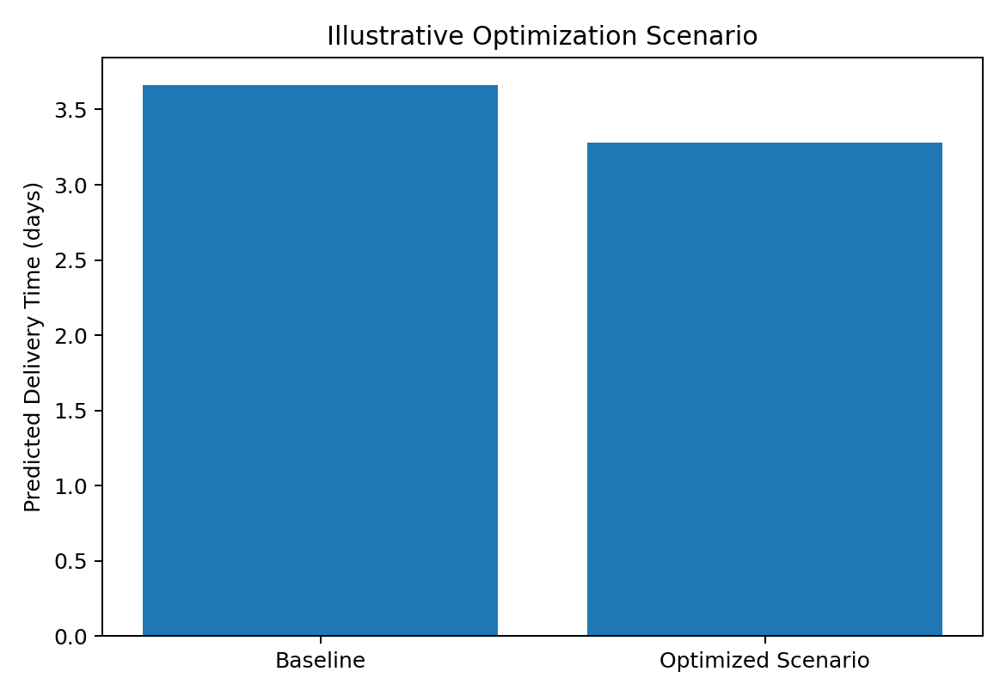
Figure 4. Illustrative predicted delivery-time comparison before and after optimization assumptions.
For cost planning, a simple illustrative assumption was also applied: route consolidation could reduce a representative transport-cost baseline by 8% and route efficiency could reduce it by a further 5%, subject to operational feasibility. Using the median simulated transport cost of ₹2,569, the illustrative cost level after these assumptions would be approximately ₹2,235. This is not a real cost saving and should not be reported as an achieved result.

8.2 Optimization Pseudocode
for shipment in planned_shipments:
predicted_time = model.predict(shipment.features)
if predicted_time > service_target:
consider_shorter_feasible_route()
check_vehicle_capacity()
consolidate_compatible_shipments()
allocate_additional_operational_support()
choose_plan_with_lowest_feasible_cost()
subject_to_capacity, distance, time_window, and service constraints

9. Key Findings
- Predictive modeling converts historical-style logistics variables into an estimated delivery-time signal that can support proactive planning.
- Tree-based models are useful for this simulated problem because logistics relationships can be non-linear and interactive.
- The tuned Random Forest achieved a test MAE of 0.296 days and RMSE of 0.368 days on the simulated dataset.
- Five-fold cross-validation produced a mean R² of 0.849, providing an additional check against relying on one train-test split.
- Model predictions can be translated into operational rules such as exception alerts, resource allocation, route review, and load consolidation.
- Optimization decisions should remain subject to real-world constraints including vehicle capacity, delivery windows, road conditions, labor availability, and service commitments.

10. Actionable Recommendations
Area | Recommendation
Prediction layer | Deploy the trained model as a planning-support component that estimates expected delivery time before dispatch.
Exception alerts | Flag shipments whose predicted delivery time crosses a defined service-level threshold.
Route review | Use predicted delivery time together with route distance and cost when comparing feasible route plans.
Load consolidation | Consolidate compatible shipments where this improves vehicle utilization without violating delivery windows.
Capacity balancing | Monitor warehouse load and shift work across available facilities when service levels are at risk.
Model governance | Retrain and validate the model periodically as new logistics data becomes available; monitor drift and error by region.

11. Limitations and Responsible Interpretation
- The dataset is hypothetical and simulated; therefore the numerical performance cannot be generalized to a real company.
- Feature importance describes model behavior and does not prove that changing a feature will cause the target to change.
- The optimization scenario uses simplified assumptions and does not solve a full vehicle-routing problem with real road networks, time windows, fleet constraints, and driver schedules.
- Real deployment would require historical shipment records, reliable timestamps, route information, operational constraints, and ongoing model validation.
- Business decisions should combine model outputs with operational expertise and feasibility checks.

12. End-to-End Methodology Flow
Problem definition → data simulation → data quality checks → preprocessing → train-test split → baseline model comparison → metric evaluation → cross-validation → hyperparameter tuning → feature interpretation → optimization scenario analysis → operational recommendations.

13. Conclusion
Week 4 demonstrated how logistics analytics can progress from descriptive analysis to predictive and decision-support methods. A hypothetical delivery-time forecasting problem was defined, multiple regression models were implemented, and performance was evaluated with MAE, RMSE, R², cross-validation, and hyperparameter tuning. The tuned Random Forest was then connected to practical optimization ideas involving route planning, load consolidation, resource allocation, and exception management. The exercise provides a foundation for a future production-oriented system that combines predictive modeling with constrained route optimization and real-time operational data.

14. References and Learning Resources
- Pedregosa et al., Scikit-learn: Machine Learning in Python, Journal of Machine Learning Research.
- McKinney, W., Python for Data Analysis, O'Reilly Media.
- Hunter, J. D., Matplotlib: A 2D Graphics Environment, Computing in Science & Engineering.
- Seabold, S. & Perktold, J., Statsmodels and statistical modeling resources.
- Python documentation and Scikit-learn user documentation for regression, model selection, cross-validation, and metrics.

Appendix A – Complete Core Modeling Code
from sklearn.model_selection import train_test_split, KFold, cross_val_score, GridSearchCV
from sklearn.metrics import mean_absolute_error, mean_squared_error, r2_score
from sklearn.ensemble import RandomForestRegressor
from sklearn.pipeline import Pipeline
X = df.drop(columns=["delivery_time_days"])
y = df["delivery_time_days"]
X_train, X_test, y_train, y_test = train_test_split(
X, y, test_size=0.20, random_state=42
)
rf = Pipeline([
("preprocessor", preprocessor),
("model", RandomForestRegressor(random_state=42, n_jobs=-1))
])
param_grid = {
"model__n_estimators": [120, 180],
"model__max_depth": [8, 12, None],
"model__min_samples_leaf": [2, 4]
}
grid = GridSearchCV(
rf, param_grid=param_grid, cv=3,
scoring="neg_root_mean_squared_error", n_jobs=-1
)
grid.fit(X_train, y_train)
pred = grid.predict(X_test)
mae = mean_absolute_error(y_test, pred)
rmse = mean_squared_error(y_test, pred) ** 0.5
r2 = r2_score(y_test, pred)
print("Best parameters:", grid.best_params_)
print("MAE:", mae)
print("RMSE:", rmse)
print("R2:", r2)

Appendix B – Dataset Snapshot
region | shipment_volume | distance_km | transport_cost | fuel_cost | order_value | warehouse_load | vehicle_utilization | delivery_time_days
East | 23 | 359.40 | 3900.73 | 925.37 | 3734.35 | 0.93 | 0.63 | 4.74
North | 18 | 101.30 | 1795.06 | 561.04 | 6256.59 | 0.62 | 0.52 | 2.62
Central | 20 | 364.70 | 3959.78 | 1258.87 | 7229.26 | 0.86 | 0.90 | 4.78
East | 20 | 67.80 | 1876.08 | 390.31 | 2494.91 | 0.46 | 0.76 | 2.66
West | 18 | 58.80 | 1667.26 | 394.39 | 4116.68 | 0.71 | 0.66 | 2.84
Central | 14 | 211.70 | 2456.47 | NaN | 6209.32 | 0.66 | 0.68 | 3.30
East | 21 | 194.50 | 2442.44 | 487.57 | 3311.56 | 0.93 | 0.67 | 3.77
East | 17 | 171.40 | 2637.41 | 747.53 | 6895.66 | 0.38 | 0.67 | 3.83

